

WHICH HOLLAND THEME?

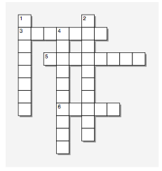

**Across**

3. You like to: Work in groups

|  |
| --- |
| Help people with problems  Participate in meetings  Do volunteer work  Work with young people  Play team sports  Serve others |

5. You like to : Attend concerts, theatres, art exhibits

|  |
| --- |
| Read fiction, plays, and poetry  Work on crafts  Take photographs  Express yourself creatively  Deal with ambiguous ideas |

6. You like to: Tinker with machines/vehicles

|  |  |  |  |
| --- | --- | --- | --- |
| Work outdoors  Use your hands  Be physically active  Build things  Tend/train animals  Work with electronic equipment  **Down**  1. You like to: Explore a variety of ideas   |  | | --- | | Use computers  Work independently  Perform lab experiments  Read scientific or technical journals  Analyze data  Deal with abstractions  Do research  Be challenged |   2. You like to: Follow clearly defined procedures   |  | | --- | | Use data processing equipment  Work with numbers  Type or take shorthand  Be responsible for details  Collect or organize things |   4. You like to: Make decisions affecting others   |  | | --- | | Be elected to office  Win leadership or sales award  Start your own service or business  Campaign politically  Meet important people  Have power or status | |