

REALISTIC

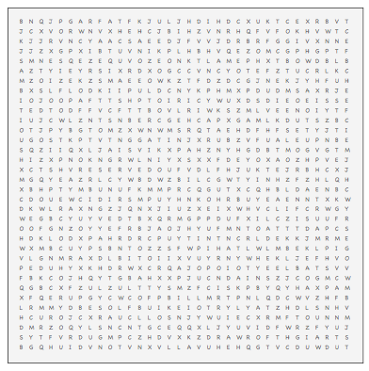

AMBITIOUS A NATURE LOVER ATHLETIC CONCRETE CURIOUS ABOUT THE PHYSICAL WORLD FRANK

INDEPENDENT MECHANICALLY INCLINDED THRIFTY

PRATICAL RESERVED SEF-CONTROLLED STABILE

STRAIGHTFORWARD SYSTEMATIC