

INVESTIGATIVE

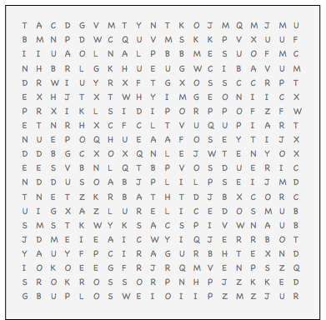

ANALYTICAL BROADMINDED CAUTIOUS

COMPLEX CURIOUS INDEPENDENT PRECISE

INQUISITIVE LOGICAL OBSERVANT RESERVED

SCHOLARLY SCIENTIFIC