

ENTERPRISING 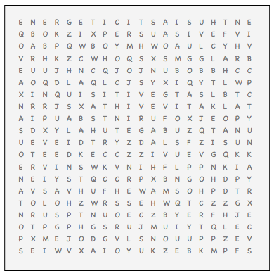

ADVENTEROUS AGREEABLE AMBITIOUS

ASSERTIVE ENERGETIC ENTHUSIASTIC

EXTROVERTED IMPULSIVE INQUISITIVE

PERSUASIVE POPULAR SELF-CONFIDENT

SOCIALABLE SPONTANEOUS TALKATIVE