

CONVENTIONAL

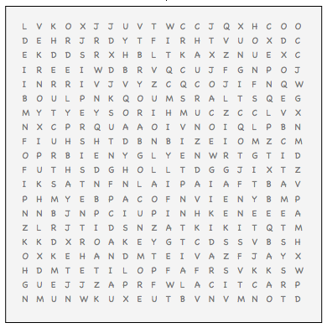

ACCURATE AMBITIOUS CONFORMING CONSCIENTIOUS EFFICIENT METHODICAL

NUMERICALLY INCLINED OBEDIENT ORDERLY

PERSISTENT POLITE PRATICAL STRUCTURED

SYSTEMATIC THRIFTY WELL ORGANIZED