PERSONAL MOTIVATORS

CLAMS:



Finding the right environment to suit your needs is very important in order to have meaning in your work. People who take a job just to make money are less likely to be satisfied, and enjoy an ideal balance between quality of life, personal values and their career/occupation.

**Take some time to write down what each of the motivators means to you and then rank them in order of importance.**



**CHALLENGE**

is what keeps many people engaged, invested and stimulated. It makes us use all our resources and inspires us to learn more and go farther.

What has been your biggest challenge to date? Were you able to complete it as planned? What part was the most challenging? What did you learn from it? Did it test your abilities and strengths? What would you do different if you could redo it? Did it inspire you to go further?

* ­­­­­­­­­­­____________________________
* ____________________________
* ___________________________
* __________________________

 

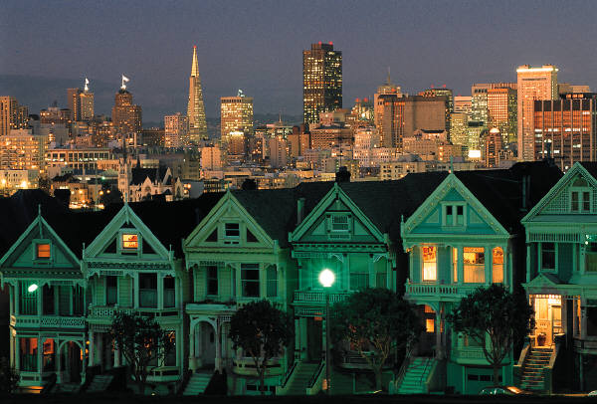  

**LOCATION** refers to the actual environment and the distance between work and home. It can be a blended concept taking in where you work (physical location), your job environment (RAISEC themes) and the actual time it takes to travel from point A to B.

What type of environment do you thrive in? Refer to your EPICS results to help discover specific characteristics that you feel good in. What is the noise level like? Are you indoors or outside? Working in a group? Team? Solo? What mode of transportation will/do you use? What is the travel time?

* ______________________________________________________________
* ______________________________________________________________
* ______________________________________________________________
* ______________________________________________________________
* ______________________________________________________________

   

**ADVANCEMENT** can be referring to status (climbing the “corporate” ladder), gaining recognition in their field (Academics...), learning new skill sets or a combination of these.

What does advancement mean to you? Does it mean changing positions within one company or changing companies with each new position? Does advancement mean acquiring new skills, degrees and certificates? What is your goal for advancement? What is the desired outcome?

* ______________________________________________________________
* ______________________________________________________________
* ______________________________________________________________
* ______________________________________________________________
* ______________________________________________________________



**MONEY** is our salary that we use to sustain our quality of life (pay bills, feed our families, provides entertainment…). We need a minimum amount to meet our daily and financial obligations.

What are your financial obligations? What is your total monthly living expense?

Rent/Mortgage

Electric/Heat/Water/Gas/Phone(s)

Cable/Internet

Food/Drinks

Restaurant/Entertainment

Credit Card (s)

Loan (s) (Auto, Student, Business)

Other



**SECURITY** refers to one’s job and how it relates to predictability in the future. Having job security means ongoing employment, meeting your basic needs, and hopefully, maintaining a quality of life for yourself and family.

What does security mean to you? Is it financial, working in an environment that makes you feel positive, alive and interested or is being supported by family, friends and loved ones? Is it your home, your job, viable transportation? Is it having money in the bank, insurance, a life plan?

* ______________________________________________________________
* ______________________________________________________________
* ______________________________________________________________
* ______________________________________________________________
* ______________________________________________________________