

ARTISTIC

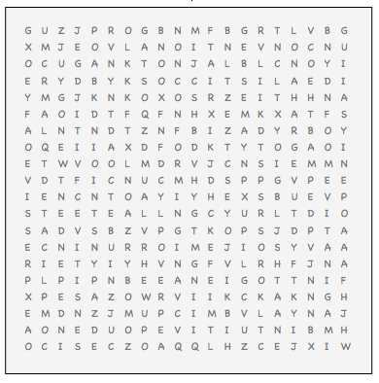

COMPLICATED COURAGEOUS CREATIVE EMOTIONAL EXPRESSIVE IDEALISTIC IMAGINATIVE IMPULSIVE OPEN

INDEPENDENT INNOVATIVE INTROSPECTIVE INTUITIVE

NONCONFORMING ORGINAL SENSITIVE UNCONVENTIONAL